Assignment 1

Task 1: Line plot.

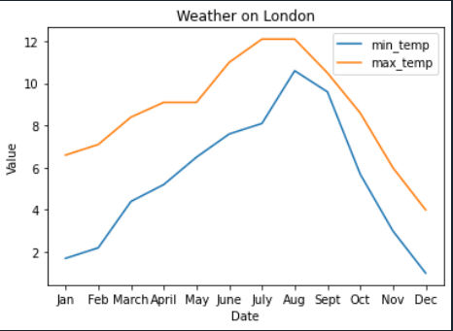

1. Line Plot A line plot is a great way to visualise trends over time or changes in values over a continuum. For example, you can use a line plot to show how the average temperature changes throughout the year or how the stock price of a company changes over time.

From this plot, we can draw conclusions about the trends and relationships between the variables over time. For example, we can see if there are any seasonal patterns, if there are any correlations or divergences between the variables, and if there are any significant changes in the values over time.

1. Bar Plot

A bar plot is a great way to visualise categorical data or comparisons between different groups. For example, you can use a bar plot to show the distribution of a variable across different categories or the performance of different teams in a competition.

From this plot, we can draw conclusions about the distribution of values across different categories or the differences in performance between different groups.

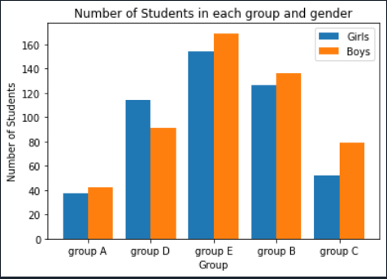

Task 3: Pie Chart

